WAIST

# Objective:

The Smith & Nephew’s WAIST developed using VBA customizations need to be converted to .NET framework in compatible with AutoCAD 2018, adhering to best practices, supporting 64 bit architectures.

# Overview:

WAIST has 3 functions “Body”, “Leg” and “Figure” to draw Waist Body details, Leg details and Figure details in AutoCAD.

This document gives an outline of input details need to generate required output, working flow and output details of WAIST module in Smith & Nephew project.

# Description:

# Scope:

* WAIST module is used to draw Waist Body, Left Leg and Right Leg block references in the standard template drawing “SN.dwt” using the details from “MAINPATIENTDETAILS” block reference.
* For WAIST module, first we need to update the attributes of “MAINPATIENTDETAILS” block reference using NEWPATIENT command. Without that, we can’t run WAIST module

# Technology:

We are using VB.net technology and AutoCAD 2018 for WAIST.

# Deliverable:

AutoCAD 2018 customized plug-in DLL.

# Steps to Run:

1. Open AutoCAD 2018 and open a drawing using “SN.dwt” template file.
2. Run NETLOAD command in Command prompt.
3. Load the updated “SmithNephew.dll” file in AutoCAD.
4. Run NEWPATIENT command in Command Prompt and update the attribute values in “MAINPATIENTDETAILS” block reference.
5. Run WAIST command in Command Prompt.
6. “Waist” dialog will be opened.
7. In that dialog, we have 3 tabs (Body, Leg and Figure).
8. Enter the required details for required Part (Body or Leg or Figure).
9. After entering details, click save button.
10. Now, the required Waist Body or Left Leg or Right Leg block reference will be drawn successfully in AutoCAD.

# Dialog Design:

# Body:

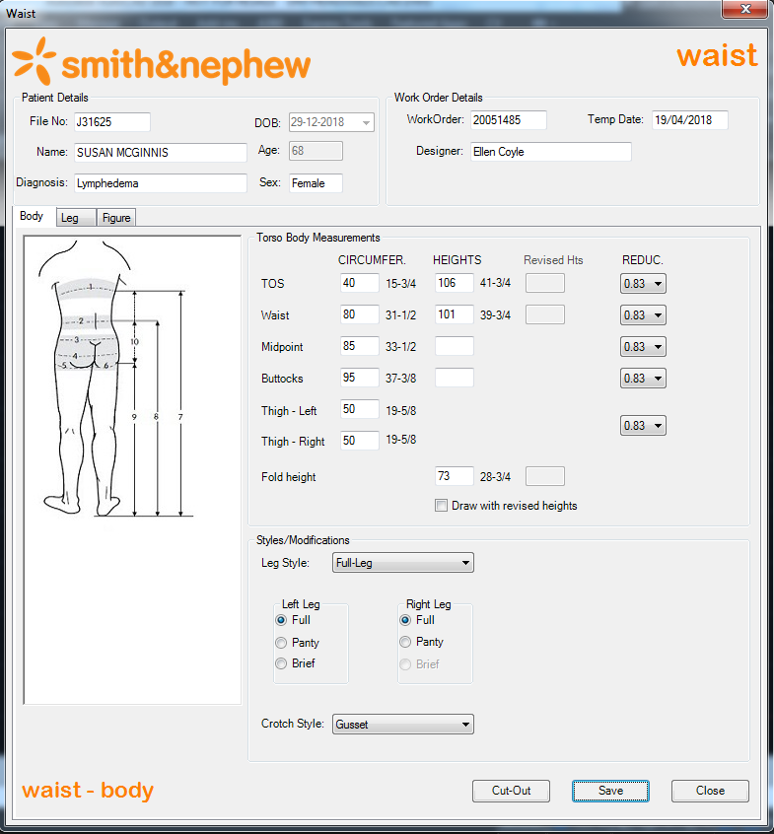

# Leg – Left Leg:

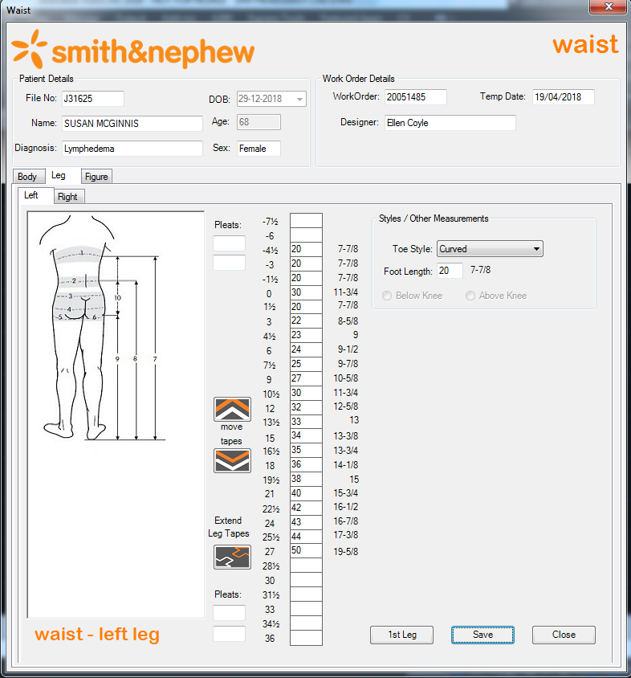

# Leg – Right Leg:

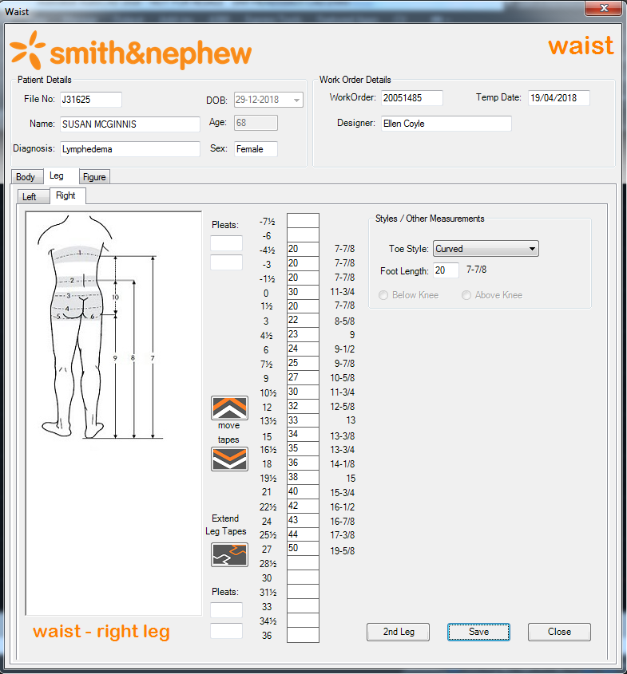

# Figure:

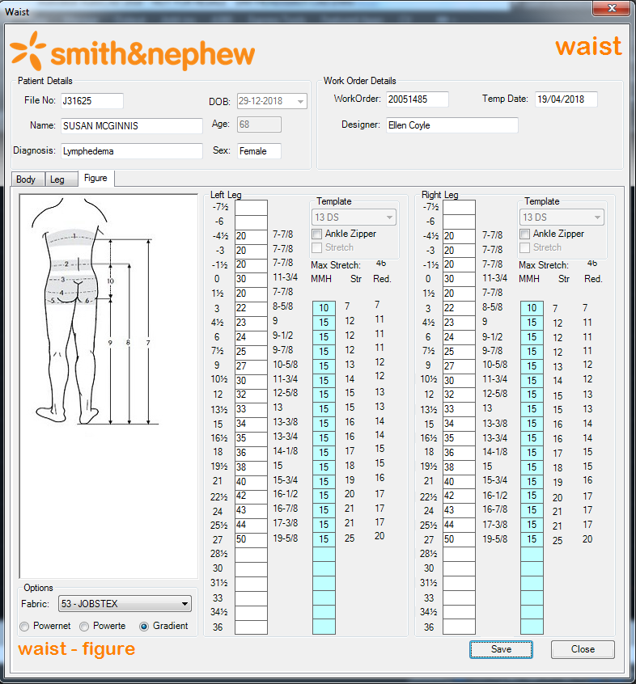

# Note:

Figure is only used to update the attribute values of Waist Body, Left and Right Leg block references. It does not produce any separate output.

# Required Output:

# Body:

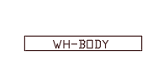

# Body – Cut-Out:

* For 1st Leg and 2nd Leg in Left and Right Leg tab, we need to draw Cut out using “Cut-Out” button in Body tab.
* To draw Cut out, first we need to save Body details. Because it reads some attribute values from Waist Body block reference.

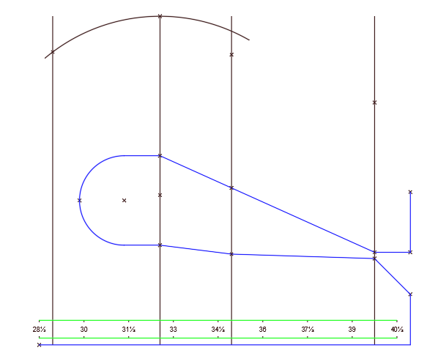

# Leg:

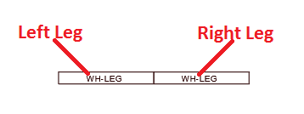

# Note:

For 1st Leg and 2nd Leg, first we need to save Figure details.

# Left Leg – 1st Leg:

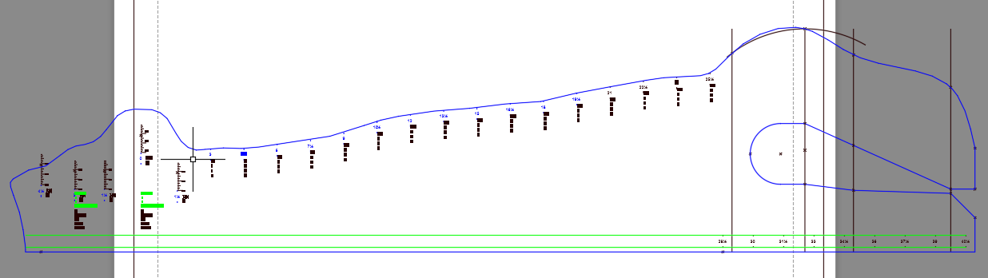

# Right Leg – 2nd Leg:

